Fixed-wing Lesson 4 Lateral-Directional Model

[1. Introduction to Lateral-Directional Dynamics](https://classroom.udacity.com/nanodegrees/nd787/parts/ee7d5970-d39c-4355-952e-ce760e701827/modules/2dd61f74-6310-4f18-98b2-e4a9a9450f85/lessons/bbbd0d64-490c-42ec-b9cb-b3527aafc38b/concepts/58645c8b-f792-4d21-a73b-a5aadfb2880a)

<https://www.youtube.com/watch?v=vlvIUyhyvE4>

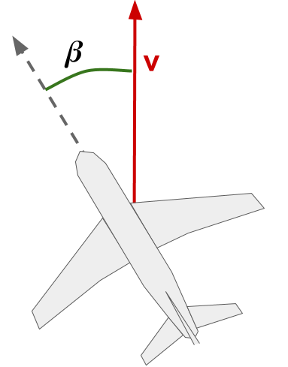



[2. Force-Free Motion](https://classroom.udacity.com/nanodegrees/nd787/parts/ee7d5970-d39c-4355-952e-ce760e701827/modules/2dd61f74-6310-4f18-98b2-e4a9a9450f85/lessons/bbbd0d64-490c-42ec-b9cb-b3527aafc38b/concepts/cc0b6fc1-0287-4619-ba87-78c78f625640)

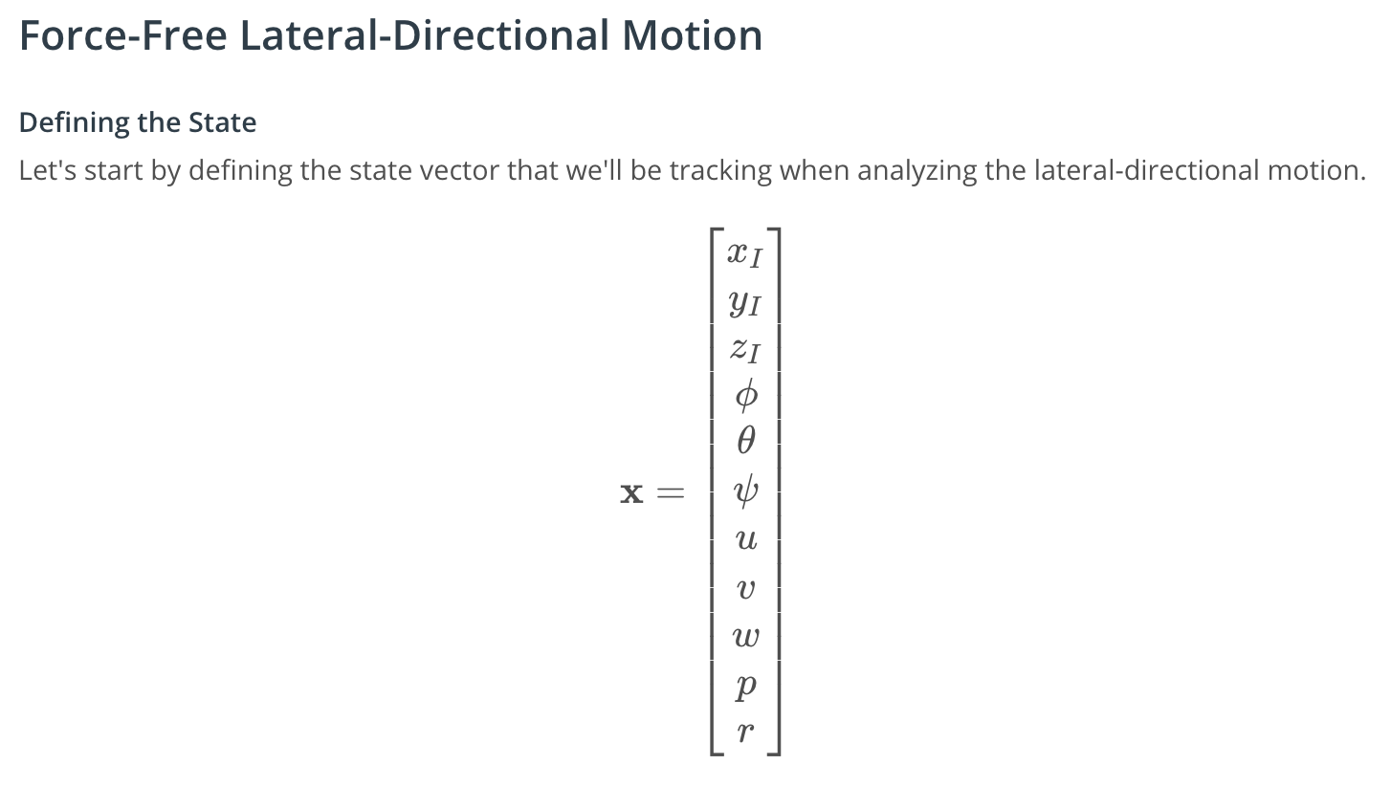

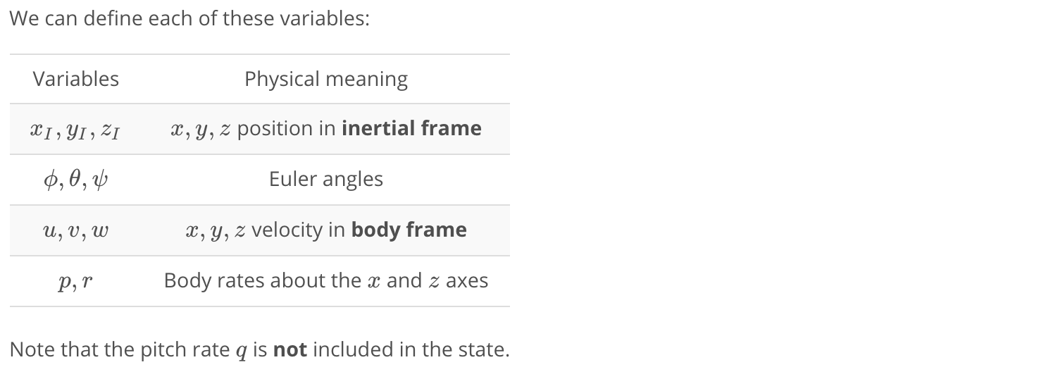

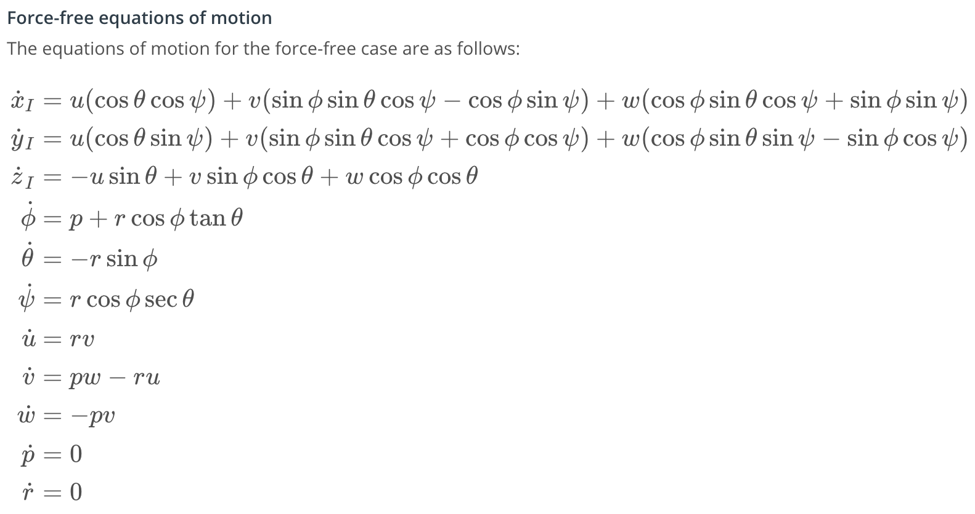

### **Reminder: Fixed Wing Cheat Sheet**

You can find all of the equations for this module in the [Fixed Wing Cheat Sheet](https://www.overleaf.com/read/cvqmtzyhqjnj).

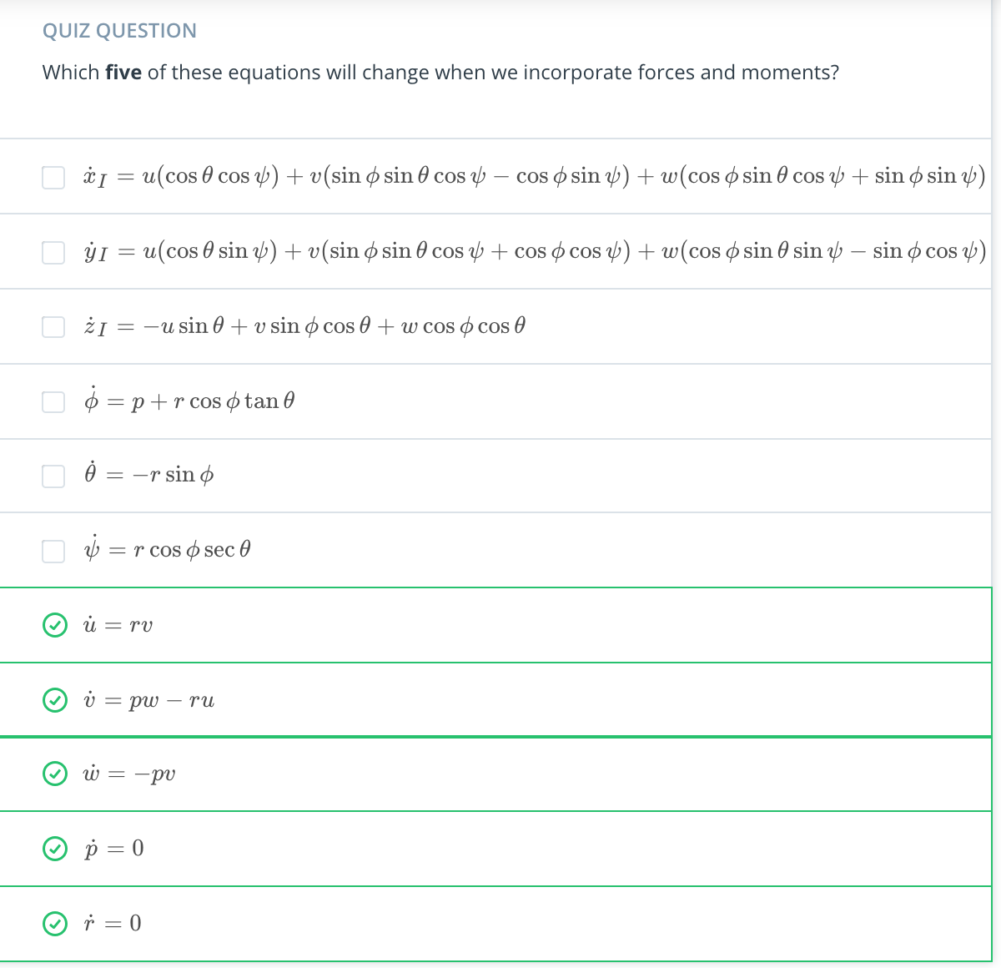

[3. Incorporating Forces](https://classroom.udacity.com/nanodegrees/nd787/parts/ee7d5970-d39c-4355-952e-ce760e701827/modules/2dd61f74-6310-4f18-98b2-e4a9a9450f85/lessons/bbbd0d64-490c-42ec-b9cb-b3527aafc38b/concepts/c1cedbca-2f77-48db-8362-5665cf85b200)

<https://www.youtube.com/watch?time_continue=4&v=oZjryB3BpGY>

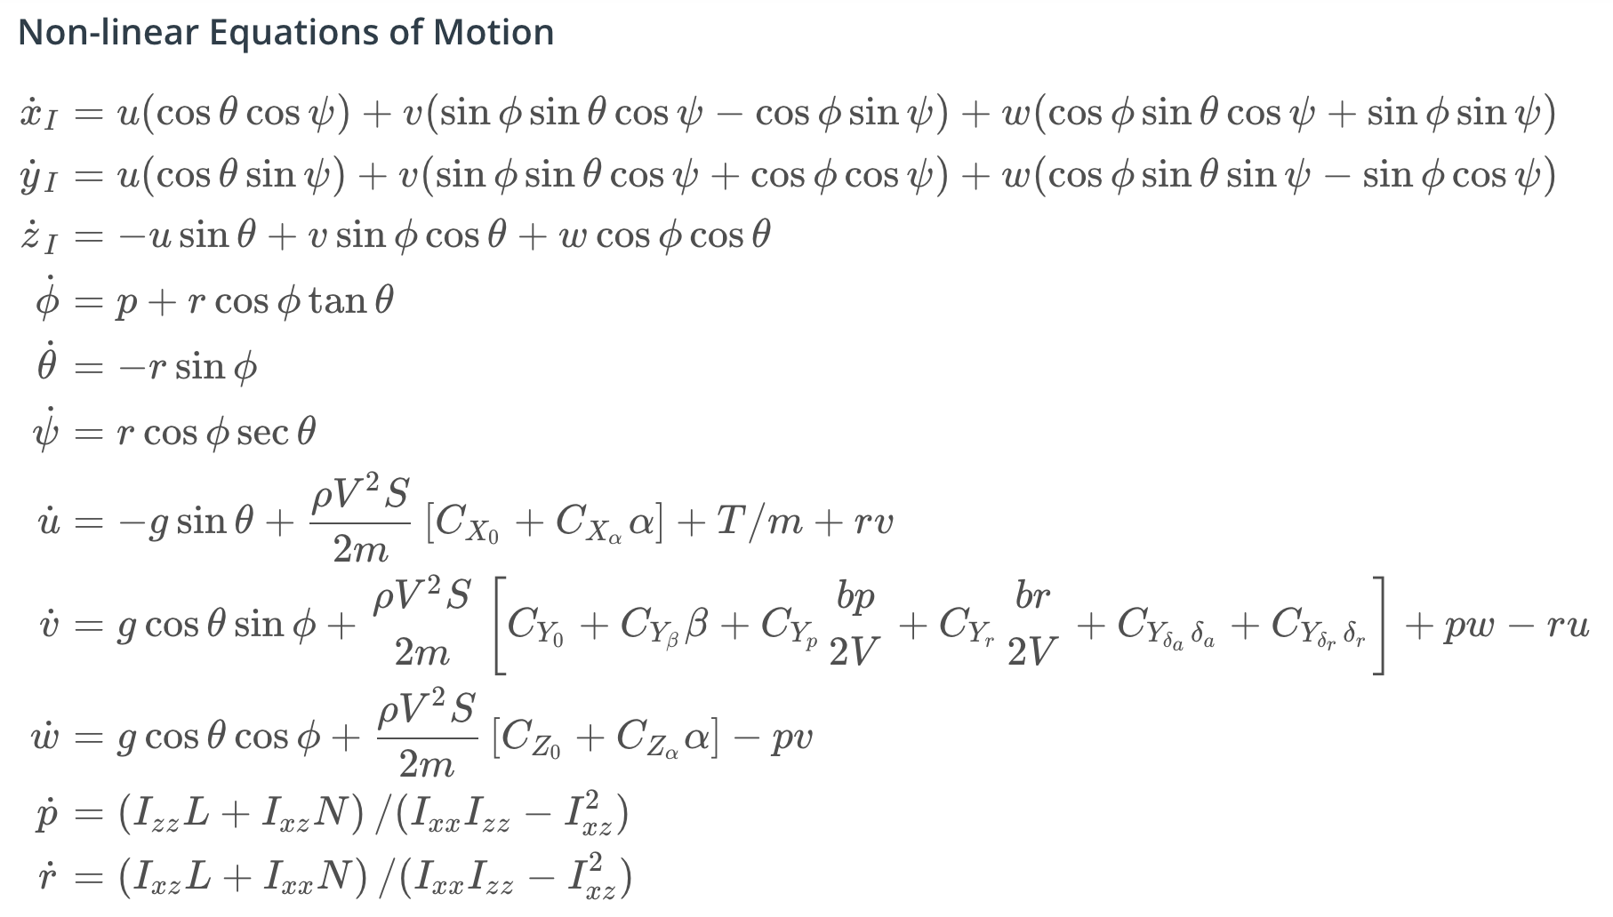

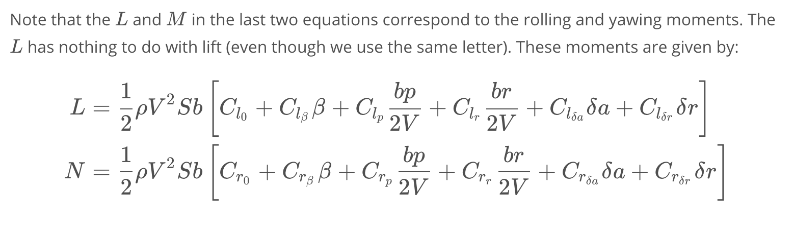

[4. Coordinated Turns](https://classroom.udacity.com/nanodegrees/nd787/parts/ee7d5970-d39c-4355-952e-ce760e701827/modules/2dd61f74-6310-4f18-98b2-e4a9a9450f85/lessons/bbbd0d64-490c-42ec-b9cb-b3527aafc38b/concepts/8c6a76d1-5217-4f39-ab74-c6779da0bc23)

<https://www.youtube.com/watch?v=hQYoItsBUeQ>

[5. Roll-Yaw Coupling](https://classroom.udacity.com/nanodegrees/nd787/parts/ee7d5970-d39c-4355-952e-ce760e701827/modules/2dd61f74-6310-4f18-98b2-e4a9a9450f85/lessons/bbbd0d64-490c-42ec-b9cb-b3527aafc38b/concepts/688ee679-87a8-4b7d-b064-33b9522443c6)

# **Roll-Yaw Coupling**

In a coordinated turn, we can turn sideways by rotating our lift vector. This lets us turn without experiencing sideforce! This is a bit unintuitive, and in general lateral-directional motion is more complicated than longitudinal motion.

In particular, roll and yaw are physically coupled in a way that leads to more complex dynamics.

To understand this roll-yaw coupling, we need to think about **how** lift is generated.

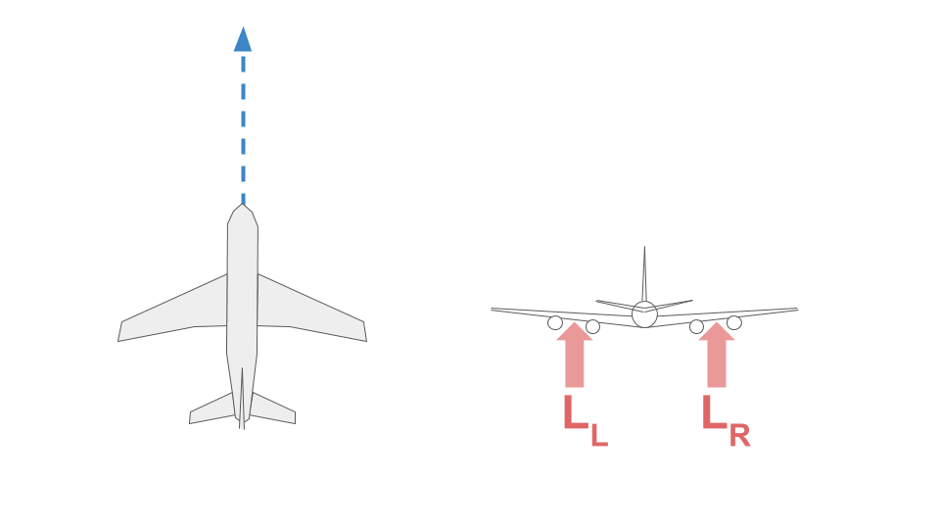

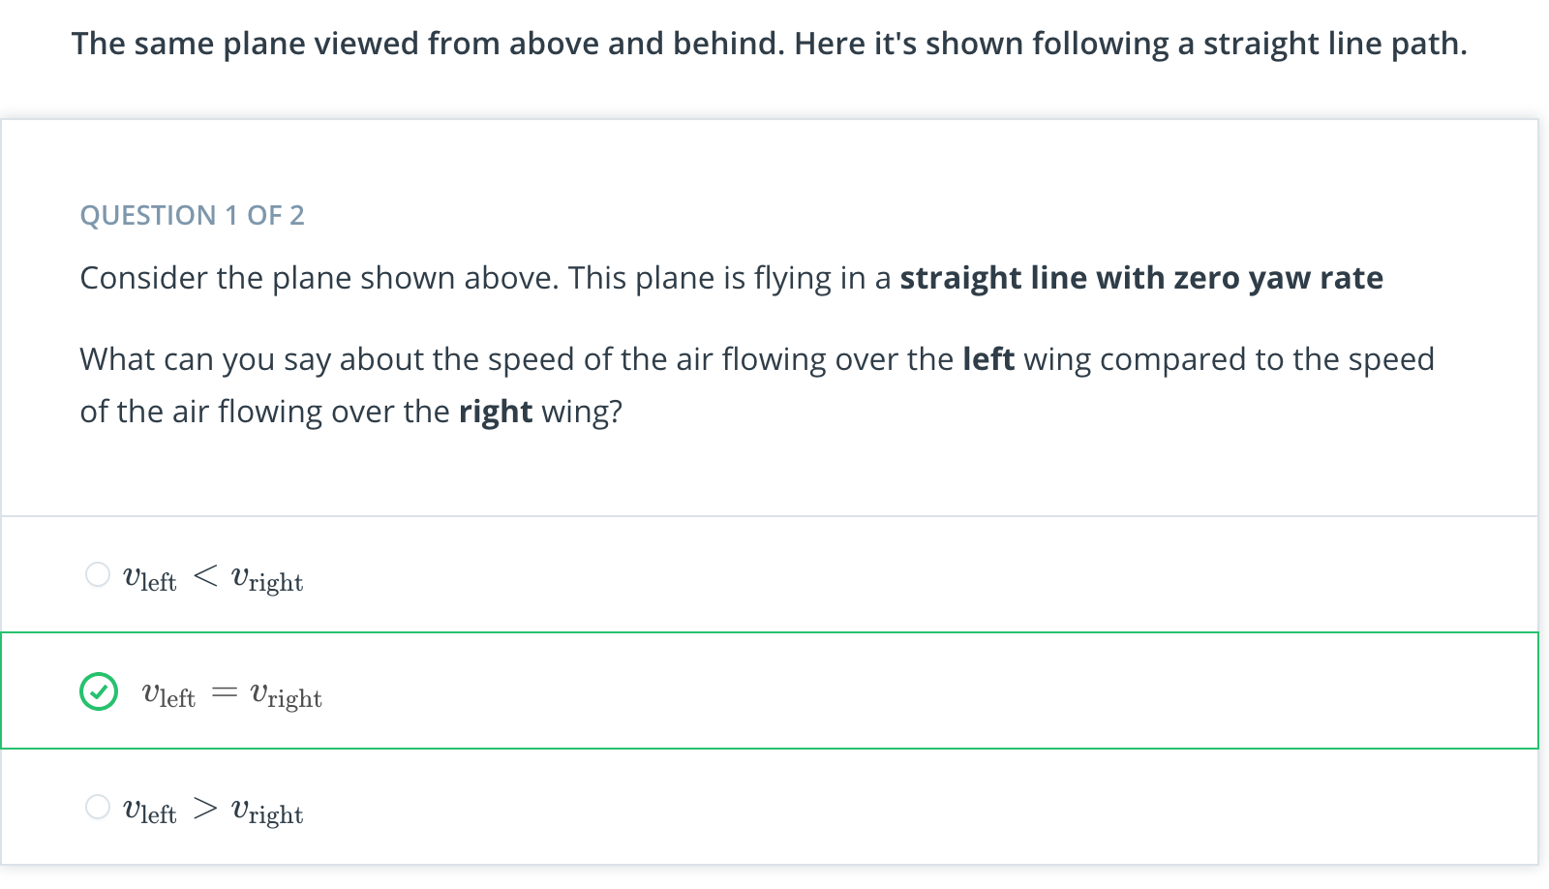

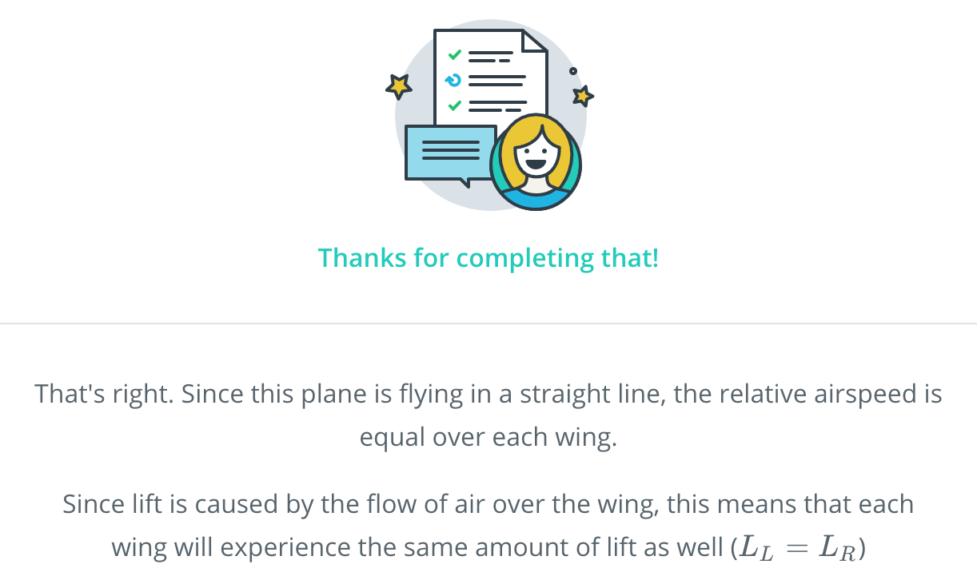

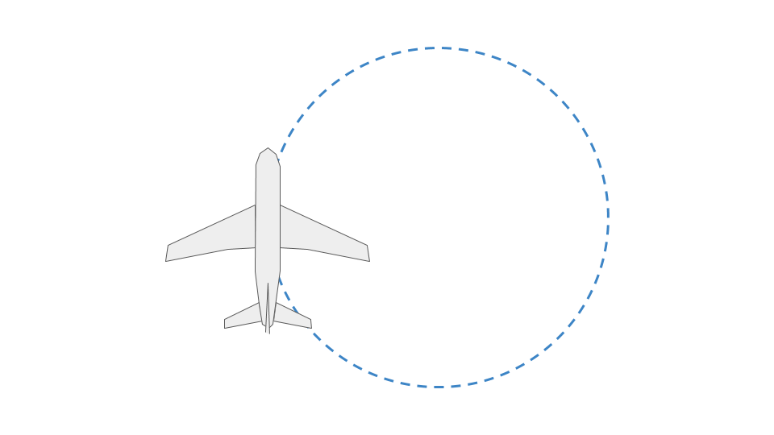

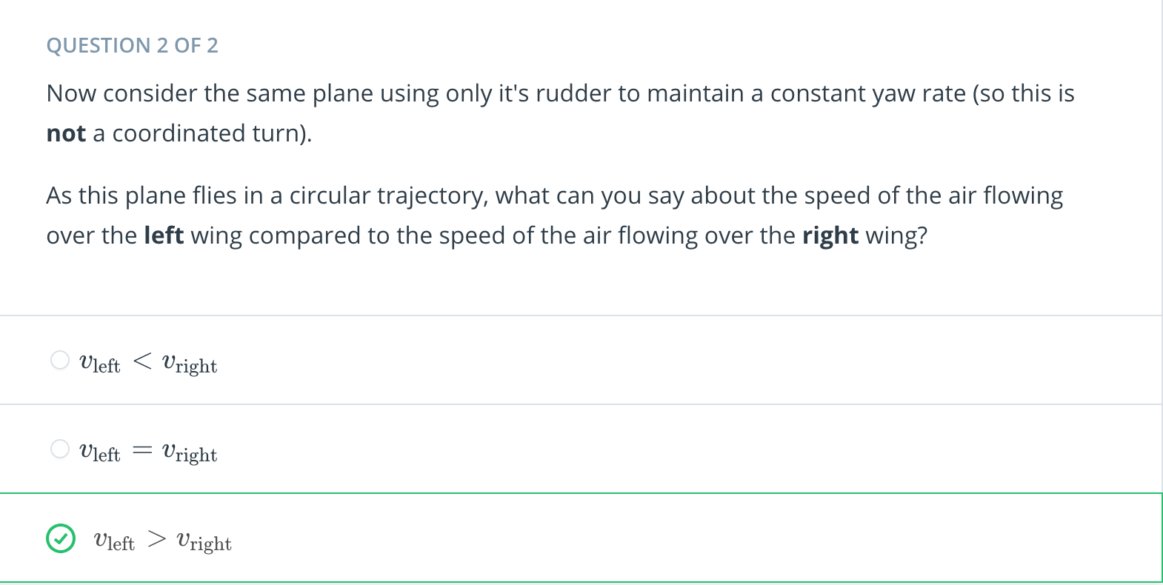

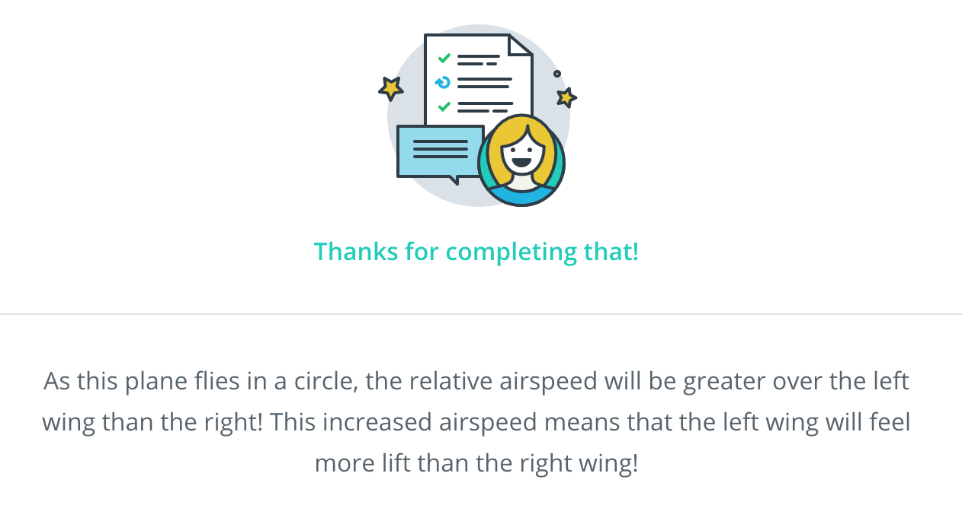

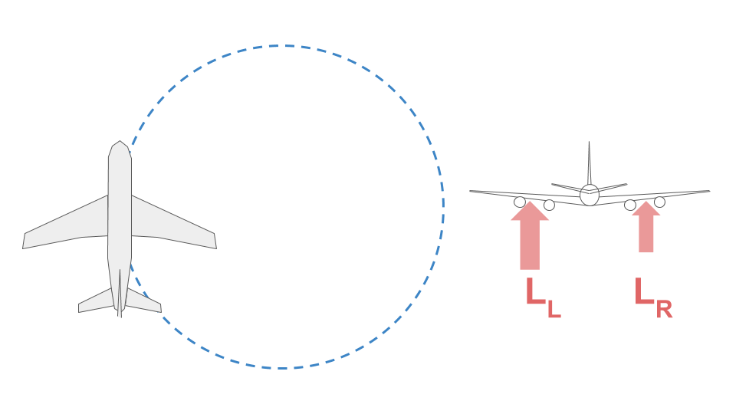

The increased relative airspeed over the left wing causes the left wing to feel more lift than the right wing.

This increased lift will cause a rolling moment that will cause the plane to roll clockwise.

The takeaway message here: **yaw and roll are physically coupled**. This coupling is what underlies the "Dutch Roll" mode, which you'll learn more about later.

[6. Static Stability](https://classroom.udacity.com/nanodegrees/nd787/parts/ee7d5970-d39c-4355-952e-ce760e701827/modules/2dd61f74-6310-4f18-98b2-e4a9a9450f85/lessons/bbbd0d64-490c-42ec-b9cb-b3527aafc38b/concepts/8a09757d-6c5d-45f6-ac4e-c41013c2f80c)

<https://www.youtube.com/watch?v=Bmg66oeHXG0>

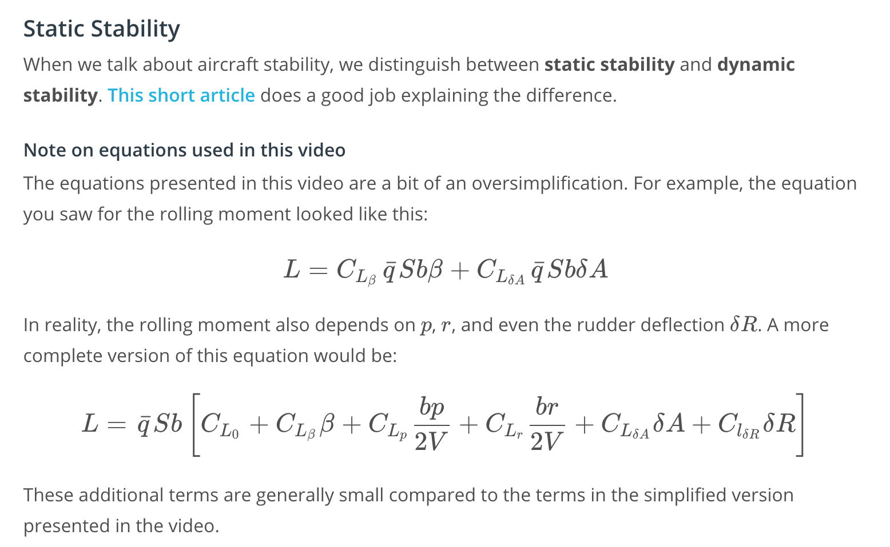

[7. The Rest of the Lesson](https://classroom.udacity.com/nanodegrees/nd787/parts/ee7d5970-d39c-4355-952e-ce760e701827/modules/2dd61f74-6310-4f18-98b2-e4a9a9450f85/lessons/bbbd0d64-490c-42ec-b9cb-b3527aafc38b/concepts/13929241-cb81-4615-8a44-049c76c61585)

<https://www.youtube.com/watch?v=C5wdgT7aOTE>

[8. Linearized Model](https://classroom.udacity.com/nanodegrees/nd787/parts/ee7d5970-d39c-4355-952e-ce760e701827/modules/2dd61f74-6310-4f18-98b2-e4a9a9450f85/lessons/bbbd0d64-490c-42ec-b9cb-b3527aafc38b/concepts/f56dd7d1-9a4c-4b2f-8daa-8d23bafd328d)

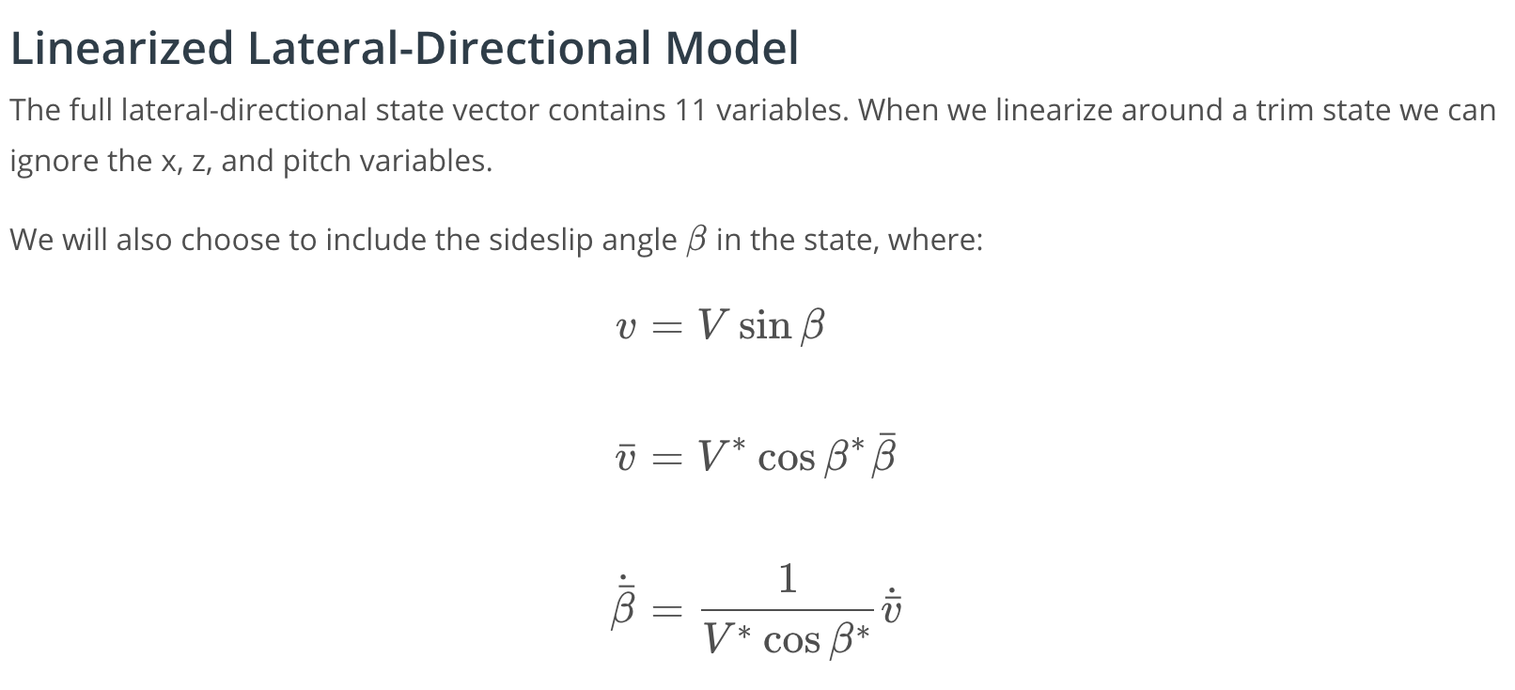



Take a look at the [fixed wing cheat sheet](https://www.overleaf.com/read/cvqmtzyhqjnj) for a more detailed explanation of the various coefficients.

[9. Identifying Dynamic Modes](https://classroom.udacity.com/nanodegrees/nd787/parts/ee7d5970-d39c-4355-952e-ce760e701827/modules/2dd61f74-6310-4f18-98b2-e4a9a9450f85/lessons/bbbd0d64-490c-42ec-b9cb-b3527aafc38b/concepts/cdcef54b-e629-43d0-abc8-8ef0fec55522)

# **Identifying Dynamic Modes**

In this exercise you will have the chance to work with a partially-implemented linearized lateral-directional model.

You have the option of completing this exercise yourself (Linearized Lateral model-Student.ipynb) or reading/working through the solution (Linearized Lateral model-Solution.ipynb).

[Linearized Lateral model-Student.ipynb](https://viewrjg6bpzb77.udacity-student-workspaces.com/notebooks/Linearized%20Lateral%20model-Student.ipynb)

[10. Stability Analysis 1: Roll Mode](https://classroom.udacity.com/nanodegrees/nd787/parts/ee7d5970-d39c-4355-952e-ce760e701827/modules/2dd61f74-6310-4f18-98b2-e4a9a9450f85/lessons/bbbd0d64-490c-42ec-b9cb-b3527aafc38b/concepts/ce8550b3-f119-4e76-8407-31b7ea91e29d)

<https://www.youtube.com/watch?v=dohXBQOl8QM>

[11. Stability Analysis 2: Spiral Mode](https://classroom.udacity.com/nanodegrees/nd787/parts/ee7d5970-d39c-4355-952e-ce760e701827/modules/2dd61f74-6310-4f18-98b2-e4a9a9450f85/lessons/bbbd0d64-490c-42ec-b9cb-b3527aafc38b/concepts/4174f031-5e48-4ac3-9412-11dbf6c0c6ab)

<https://www.youtube.com/watch?v=GtCNe6gBi10>

[12. Stability Analysis 3: Dutch Roll](https://classroom.udacity.com/nanodegrees/nd787/parts/ee7d5970-d39c-4355-952e-ce760e701827/modules/2dd61f74-6310-4f18-98b2-e4a9a9450f85/lessons/bbbd0d64-490c-42ec-b9cb-b3527aafc38b/concepts/cff896b7-27b4-4fa1-bd73-30e5e87193bf)

<https://www.youtube.com/watch?v=OFhzQSTRGwQ>

[13. Conclusion](https://classroom.udacity.com/nanodegrees/nd787/parts/ee7d5970-d39c-4355-952e-ce760e701827/modules/2dd61f74-6310-4f18-98b2-e4a9a9450f85/lessons/bbbd0d64-490c-42ec-b9cb-b3527aafc38b/concepts/41989b56-92ba-4e24-a8ec-429fcb94a90b)

<https://www.youtube.com/watch?v=C-K_pshzDuY>